**The Brief on Handbook of Inspiration Economy**

**By Dr Mohamed Buheji – coming Feb 2016**

This first Handbook on Inspiration Economy comes in a time where the world is changing very fast in terms of its speed, challenges, development and opportunities. The author and founder of the concept, Dr Mohamed Buheji, first discusses the essence of having a handbook dedicated to Inspiration-based Economy. The book discusses the history of inspiration, then discusses inspiration as an important life asset, away from being a supernatural source. Then, the characteristics of inspiration creator are explored in detail. This handbook also sets a reference between inspiration from perspiration to creativity and innovation. Levels of 'Inspiration Cultures' are discussed. This is followed by a discussion of the role of inspiration in creating better life insight.

The handbook tries to create, realise, and visualise the demands for Inspiration Economy (IE) and list them in relevance to IE, i.e. how inspiration affects the socio-economy, Quality of Life and Social Cohesion. Dr Buheji sets new terms in relevance to “Inspiration Assets” and "Spirit of Inspiration in Research", "Practices of an Inspiration Economy", "Inspiration Economy Mind-set", "Economics of Inspiration".

The author dedicates a full chapter for understanding the relations between 'Economy and Psychology', in relevance to many important areas to socio-economy stability and sustainability as the Feelings, the happiness, the Life Satisfaction, the Economics of Perfection and the Economics of Wellbeing.

Hormones of Inspiration are briefly discussed in relation to the Economic Approaches and Social Psychology along with the Inspiration Insight and Positive Affects.

Strong focus was on Inspiration Economy Enablers whether these arerepresented in the IE Sources or IE processes. Studies on the relation of these enablers and education, experience, humbleness, or human giving and inspiration are presented.

Inspiration Labs©, a technique that was developed by Dr Buheji, is briefly discussed here to improve the organizational and business design. The handbook shed a light on the relation of style of Learning, ability to focus and Inspiration. The relation between balanced life, empowerment and the creation of positive inspirational practices and policies are also discussed.

The book if full of case studies and examples in relevance to how to create or what to avoid in the journey towards optimising inspiration role in our daily lives. Subjects as Lifelong learning, youth, women, the disabled and religion are studied from perspective of inspiration. New best practices as appreciative enquiry, analogical thinking are studied to see how organisations get inspired. As with any other theory the inspiration economy focuses on specific tools and start with setting a generic life plan and then shift towards using scientific method’s role in Creating Waves of Inspiration. This handbook also sheds light on the Characteristics and Measures of inspiration including the characteristics of Inspired People. The book puts the seeds for an Inspiration Economy Global Index including the IE indicators and scales of maturity.

Inspiration Economy and Future Competing Economies are discussed also as a comparative study with the different contemporary economic theories or those frameworks that address the similar aims. Then management of Inspiration Projects and Initiatives are discussed. Inspiration and the Transition, the service, the knowledge, the learning, the entrepreneurial, the homo, the purple, experiential economies are discussed. Lots of space is given for reviewing the role of Inspiration Economy with Wellbeing and the Genuine Wealth Economy, the Empathetic Economy, and the Happiness Economy as an expected alternatives or supporting forces for future IE. The author and publishers hope the concept of Inspiration Economy inspires you!

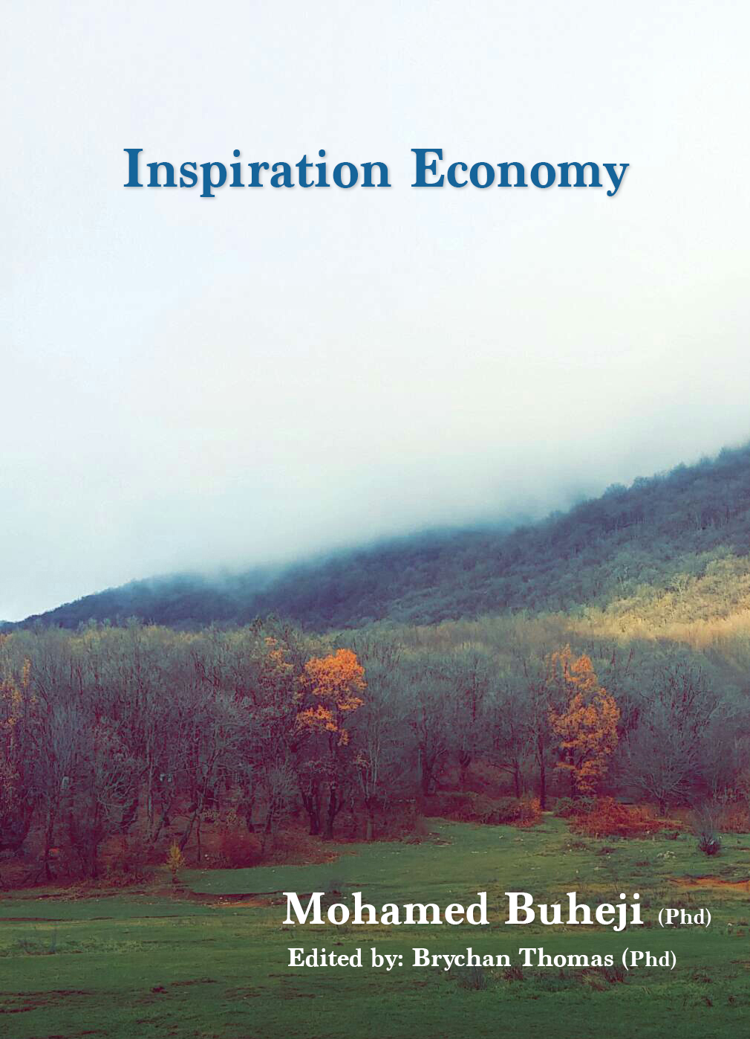

*Handbook of Inspiration Economy*

*A Comprehensive Handbook - In search for the uprising of Inspiration Economy*

*A Journey towards Inspiration and keeping inspirational spirit for life*

*Written by:*

*Mohamed Buheji, Phd*

*Edited by*

*Brychan Thomas, Phd*

*We thank all those that expressed their interest in contributing to this handbook, but couldn't do so due to limitation of time and we promise that the next series would cover more collaborative work from leading Scholars in the different disciplines and from all the continents – representing the latest thoughts, practices, initiatives, projects and research in relevance to the field of Inspiration Economy. Also, we would like to thank those who manage to contribute some important Inspiration economy practices or thoughts and where their names are mentioned in beginning of the chapter.*

*Cover of the Book Photo & Design by- Abdulla Mohamed Buheji,*

*(Photo taken from Dajti mountain – Albania)*

**For further information please contact:**

Dr Mohamed Buheji [buhejim@gmail.com](mailto:buhejim@gmail.com) , Tel +973-33388150

Personal Website: [www.buheji.com](http://www.buheji.com)

Organisation Website: [www.inspirationeconomy.org](http://www.inspirationeconomy.org/)

**Table of Contents**

Preface 9

Chapter One – Introduction to Handbook of Inspiration Economy 10

Brief Introduction about Inspiration Economy Handbook 10

Why a Handbook on Inspiration based Economy? 12

Economic Systems & Inspiration Economy 14

What is Inspiration Economy? 15

History of inspiration 16

Synopsis of Inspiration Literature 16

Inspiration as a Supernatural Source 18

Inspiration Creators (Ibn Khaldun as a model) 19

Inspiration from Perspiration to Creativity 22

Relation between Innovation and Inspiration 24

Levels of Inspiration Cultures 25

Inspiration and Insight 25

Future Studies 27

Chapter Two – Demands for an Inspiration Economy 29

Society Demands & Inspiration 29

Inspiration and Human Dignity 29

Inspiration - from Impact to Influence 30

Need for Socialisation and IE 31

From Supply to Capacity vs. Demand 32

Inspiration and Quality of Life 33

Inspiration and Social Cohesion 35

Market Failure and Social Dilemmas 36

Role of “Inspiration Assets” in our society today 37

Restructuring the Economy with Inspiration 39

'Creative Class' and Inspiration Economy 41

Full World and Inspiration Economics 41

Why an Inspiration based Economy is needed? 43

The Power of Ideas Spill Over 45

The challenge of Operationalizing Inspiration. 45

Spirit of Inspiration in Research 46

Chapter Three – Foundations & Principles of 'What is an Inspiration Economy?' 48

What is Inspiration? 48

'Growth vs. Development' and the Inspiration Economy 50

Practices of an Inspiration Economy 52

Psychology and the economy 52

Inspiration through understanding the Socio-Economy 54

Social Desirability and Inspiration 55

Lifelong Learning as a source of Inspiration 56

Inspiration Economy Mind-set 57

Inspiration Economy vs. Social Behaviour 60

Social Innovation and the Inspiration Economy 61

Inspiration and Productivity 63

International Inspiration Economy Programme 65

The Economics of Inspiration 67

Youth and students in an Inspiration Economy 71

Framework of an Inspiration driven economy 72

Chapter Four– Understanding the relations between 'Economy and Psychology' 74

Economics and Psychology 74

Brain Inspirational Activities 78

The Feeling Economy 79

Happiness and Inspiration 80

Economy of Life Satisfaction 81

Inspiration and Psychology 82

Inspiration and the Economics of Perfection 85

Inspiration and the Economics of Wellbeing 86

Feelings of Inspiring Others 88

Inspiration vs. Established Concepts 89

Hormones of Inspiration 90

Economic Approaches and Social Psychology 94

Inspiration Insight and Positive Affects 95

Chapter Five – Inspiration Economy Enablers 98

Sources of Inspiration 98

Inspiration as a process 101

Between Experience and Inspiration 102

Humbleness with Objectivity as Secrets of inspiration 103

Inspiration in Higher Education 106

Education in an Inspiration Economy 108

Inspiration through Arts and Humanities 110

Inspiration through the art of Giving 111

Inspiration Labs © 111

Organizational and Business Design and the IE 117

Inspirational Leadership 117

Ideation importance to the economy 119

Evolution of Inspiration Economy 121

Style of Learning and Inspiration 122

Inspiration and the ability to Focus 124

Balanced Life as a source of Inspiration 126

Inspiration through Empowerment 126

Positive inspirational policies 127

Blockages towards inspiration 129

Inspiration and Lifelong Learning 130

Inspiration of Women and the Economy 131

Can Religions be a source of Inspiration? 133

Sources of Inspiration 134

Best Inspiration Time - Youth 134

Appreciative Enquiry as a source of inspiration 135

Analogical thinking role in an Inspiration Economy 136

Inspiration Economy and Blooms Thinking 140

Inspiration out of needs 143

Role of Lifelong Learning in Inspiration 145

Inspiration through effective Partnership 147

Understanding the minds of the inspired 148

How Smart Organisations Turn on Inspiration 149

Chapter Six – Tools & Instruments of Inspiration Economy 150

Know what is your Value in the Market? 150

Inspiration needs a generic Life Plan 151

Inspiration and Pressure of Life 152

Towards an Economy that establishes a 'Quality of Life' 153

Inspiration Economy - India as an example 155

Scientific Method’s role in Creating Waves of Inspiration 156

How to create inspiration? 158

Inspiration Mentorship 161

Spirit of Inquiry and Inspiration 162

Unique Inspiration needs a real challenge 163

Inspiration before Retirement 166

National Volunteers Programme and Inspiration 167

Self-Control and an Inspiration Economy 168

Inspiration: Moving from Involvement to Engagement 169

The Art of creating Inspiration 174

Innovation and Inspiration – 'eco-systems' 174

Practicing Inspiration – Seeing the Pig Picture 175

The 'Design Thinking' role in an Inspiration Economy 177

Measuring Inspirational Learning of Organisations 178

The Power of Focused Thoughts 179

Inspiration Economy and Profound Knowledge 181

Ecoremediations as a source for Inspiration Economy 182

Chapter 7 – Characteristics & Measures of an Inspiration Economy 189

Inspiration as a Motivator 189

Characteristics of Inspired People 190

Inspiration as a source of legacy 192

Inspiration as a process 194

Synergetic Practices and the Inspiration Process 195

Between Experience and Inspiration 196

Humbleness with Objectivity as Secrets of inspiration 197

Inspiration Economy Global Index 199

The Inspiration Economy Global Index (IEGI) 200

The Literacy of Inspiration 201

Concept and Ideas Generation 204

Inspiration as a source of influence 205

Inspiration Economy Indicators 206

Capturing Moments of Inspiration 209

Inspiration Forms, Frequency and Intensity 210

Anatomy of Inspiration 211

Inspiration Scale 212

Measures of an Inspiration Economy’s Maturity 215

Ethics of an Ecological Economy 215

Chapter Eight – Outcomes of an Inspiring Economy 217

Inspired Communities 217

Inspiration Economy and Agility 217

Inspiring Organisations 218

Social Entrepreneurship and an Inspiration Economy 221

Heritage and Inspiration 222

Inspiration Shaping Change in Our Societies 223

Inspiration with Aging Societies 224

People’s wellbeing and Inspiration performance 225

Inspiring Governments 227

Inspiration and Resilience 229

Benefits of an Inspiration Based Economy 231

Inspiration leads to Innovation and Creativity 232

Inspiration’s influence on NPOs 237

Chapter Nine – Inspiration Economy and Future Competing Economies 238

Management of Inspiration Projects and Initiatives 238

A Holistic Approach and Inspiration 239

Inspiration and the Transition economy 239

Inspiration and the Service Economy 240

Inspiration and the Knowledge Economy 241

Inspiration and the Learning Economy 243

Inspiration and the Entrepreneurial Economy 244

Inspiration and the Homo Economy 245

Inspiration and the Purple Economy 246

Inspiration and the Experience Economy 247

Inspiration, Wellbeing and the Genuine Wealth Economy 249

Inspiration Economy and Neuroconomy 251

Inspiration and the Empathetic Economy 251

Inspiration and Gamification 253

Inspiration and the Happiness Economy 254

Inspiration Economy and Future Generations 256

Inspiration Economy and Holistic thinking 257

Inspiration and Economic dynamics 258

Inspiration Programme Initiatives 259

Capitalising on Inspiration 261

Future of the Inspiration Economy 261

Final Note 264

References 271

Appendix 292

Introduction to International Institute of Inspiration Economy 292

What is Inspiration Economy for IIIE? 293

Establishment of International Institute of Inspiration Economy 294

Sample of an "Inspiration Labs©" Introductory Workshop 294

A brief about the Author 300